Hamilton Central R. P. Club
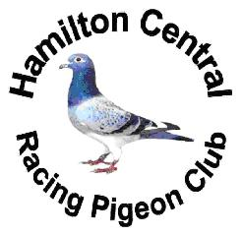

2012 Members

MEMBERS FOR 2012.

1. A.Abdullan
2. S.Armour
3. S.Burdzinski
4. A.Chambers
5. E.Composilvan
6. T.Chyl
7. J.Davitson
8. J.Doise
10. J.Eerenberg
11. J.Erwin
12. E.Fowler
13. J.Giankos
14. P.Hatzis
15. T.Humberston
16. B.Kirkelos
17. L.Koper
18. K.Lawrie
19. B.Leibfritz
20. G.Lindley
21. H.Lebreton
22. J.Malec
23. A.Merlo
24. R.Morris
25. M.Olejnik
26. N.Oud
27. P.Phelan
28. M.Racz
29. V.Radoman
30. A.Rasoul
31. S.Rebejko
32. R.Ruber
33. G.Schuur
34. W.Schwoob
35. G.Sharples
36. J.Soltysik
37. B.Szucsko
38. P.Tavares
39. B.Taylor
40. J.Silva
41. J.Zagrodzki
42. J.Zapora

Honorary members Benny DeJonge , Paul Stefanik , Jerry Oleksiuk

The Club House is located at 414 Highland Road East in Hamilton Ontario

Our clubhouse is available for all activities pertaining to our sport !

Shippings, meeting, shows, auctions, etc. !

Lots of Parking Space !

We would like to thank all the people who donated to our young bird auction !

